Title

First_name Last_name

Submitted to the
Department of Computer Science and Information Technology
in Partial Fulfilment of the Requirements for the Degree of
Bachelor of Science in Computer Science
at the Naresuan University
November 2020
Copyright of Naresuan University. All rights reserved.
Title

by
First_name Last_name
Submitted to the
Department of Computer Science and Information Technology
in Partial Fulfilment of the Requirements for the Degree of
Bachelor of Science in Computer Science

Committee

……………………………….........………...........................Advisor
(Associate Professor John Smith, Ph.D.)

……………………………….........………...........................Committee Member
(Jane Doe, Ph.D.)

……………………………….........………...........................Committee Member
(John Snow, M.S.)

…………………………….........………................................…
(Assistant Professor Sanya Khruahong, Ph.D)
Head of Department of Computer Science and Information Technology
November 6, 2020

Acknowledgement
…………………………………………………………………………………………………………………………………………………………………………………………………………………………………………………………………………………………………………………………………………………………………………………………………………………………………………………………………………………………………………………………………………………………………………………………………………………………………………………………………………………………………………………………………………………………………………………………………………………………………………………………………………………………………………………………………………………………………………………………………………………………………………………………………………………………………………………………………………………………………………………………………………………………………………………………………………………………………………………………………

First_name Last_name
Title Title
Author First_name Last_name
Student ID 60xxxxxx
Advisor Associate Professor John Smith, Ph.D.
Co-advisor Jane Doe, Ph.D.
Academic Paper Undergraduate Thesis B.S. (Computer Science)
Faculty of Science, Naresuan University
Keywords 3-5 words (separate by comma , )

Abstract
Use font Arial size 12 normal. The abstract should have 300-500 words.
...............................................................................................................................................................................................................................................................................................................................................................................................................................................................................................................................................................................................................................................................................................................................................................................................................................................................................................................................................................................................................................................................................................................................................................................................................................................................................................................................................................................................................................

Table of Contents
 | page
Acknowledgement | i
Abstract | ii
Table of Contents | iii
List of Tables | iv
List of Figures | v
Chapter 1 Introduction  - Introduction  - Objectives  - Scope  - Assumptions  - Definitions  - Benefits | 1  1  2  2  2  3
Chapter 2 Literature Review and Related Works  2.1 Background  2.1.1 Theory  2.1.2 Technique  2.1.3 Technology  2.2 Related Works | 4  4  5  6  8
Chapter 3 Methodology  3.1 Method  3.3 Design and Implementation  3.4 Testing | 9  11  13
Chapter 4 Results and Discussion  4.1 Results  4.2 Discussion | 14  18

Table of Contents (cont.)
 | page
Chapter 5 Conclusions  5.1 Conclusions  5.2 Limitations  5.3 Recommendations | 19  19  20
References | 21
Appendix  Appendix A : Database Schema  Appendix B : Tutorial | 22  30

List of Tables

Table |  | page
2.1 | Table name | 5
2.2 | xxxxxxxxxxxxxxxxxxxxxxxxx | 10
3.1 | xxxxxxxxxxxxxxxxxxxxxxxxx | 11

List of Figures

Figure |  | page
2.1 | xxxxxxxxxxxxxxxxxxxxxxxxx | 2
2.2 | xxxxxxxxxxxxxxxxxxxxxxxxx | 3
3.1 | xxxxxxxxxxxxxxxxxxxxxxxxx | 4

Introduction
[To make a header for each chapter, use Styles > “Heading 1” and type “Chapter 1”. Then press Shift + Enter to begin a new line for typing the chapter name. The chapter number will run automatically.]
[For each paragraph, use Styles > “Normal”. The normal style has 0.5 inch indent with font “Arial” size 12. The line spacing of paragraphs is 1.5 lines ]
[If you want to begin a paragraph with no indent, use Styles > “Normal No Indent” instead]

Introduction [use Styles > “Heading 2”]
What is your project about? Why is it important?
Are there other organizations involved in your project? How will they benefit from your project? Who will benefit?
Who are the users? What are the advantages of this project for the users?

Objectives
List the specific outcomes of your project:
How will your product help the users?
What products will you produce? An application, a website?
What will you learn from doing the project?
- Objective 1 [use Styles > “List Paragraph”]
- Objective 2 [use Styles > “List Paragraph”]

Scope
Begin here…

Assumptions (If any)
Begin here…

Definitions
Begin here…
[Whenever you want to start a new page, do not use “Enter” but use “Page Layout > Breaks > Page”]

Benefits
Begin here…

*** Do not show the page number of the first page of each chapter ***
We recommend starting a new section by using PAGE LAYOUT > Breaks > Section Break Next Page

Literature Review

Background
Describe and summarize theories, techniques, or technologies related to your work.

Related Works
What other projects or research have been done that are similar to your project? What is different to your project? Describe these related works or technologies. Include at least 3 references [1]!

[To format a figure, use Styles => “Figure”]

Figure 2.1 figure name no bold [use Styles > “Caption”]
[ To make a nice format of your figures and tables and ease for referencing, we recommend to use the MS Word function with the following steps:
- select REFERENCES > Insert Caption
- in Label choose “Figure”, see Figure 2.2
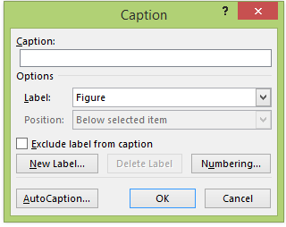
Figure 2.2 Dialog for inserting a caption
- select NUMBERING then check “Include chapter number”, see Figure 2.3
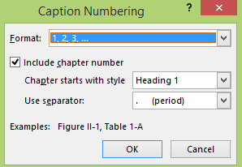
Figure 2.3 Define the numbering format of captions
- Then click OK. Type a caption by have a space between the number and the text. The text is not bold.]

[To reference a figure number in your text, you better use the function “Cross-reference”. The function will automatically update the figure number when the figure number changes. The steps using this function are as follows:
- Click “REFERENCES > Cross-reference”]
- In Reference type choose “Figure”, and In Insert reference to choose “only label and number”. Then select the figure that you want to reference. See Figure 2.4]
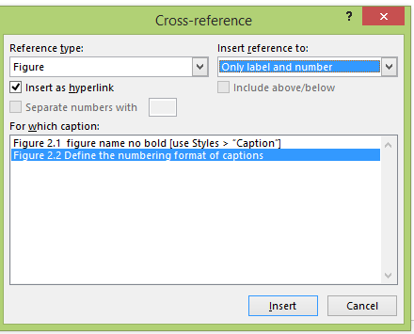
Figure 2.4 Cross-reference the figure number in text

[To make a Table caption and reference, follow the instructions above but change “Figure” to “Table”. But the caption of the table is on top of the table with left alignment.]

Table 2.1 Table name
Column 1 | Column 2 | Column 3 | Column 4 | Column 5
1
2
3
 | Total
Note: No indent for text within the table [use Style > “Normal No Indent”]

[To update the figure and table numbering, the steps are as follows:
- Select all the text in the document, Ctrl + A
- Right click then choose “Update Field”, see Figure 2.5 ]
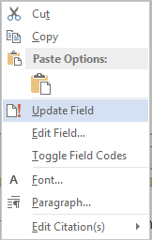
Figure 2.5 Update the figure and table numbering field

Methodology

Method
Describe tools used for developing this project and explain the purpose of using the tools.
Describe steps you take for doing the project.

Design and Implementation
Describe the stages you went through to produce your software. You might want to include: use case diagrams, class diagrams, storyboards, ER diagrams, flow charts, explanations of algorithms that you developed.
Explain how your software works from the point of view of a developer and of an end-user. Imagine someone wants to recreate your project, what do they need to know?
Include figures where appropriate, but always discuss the figure (don’t just put lots of figures with NO explanation). For an example of a correctly formatted figure, please see Figure 3.1.
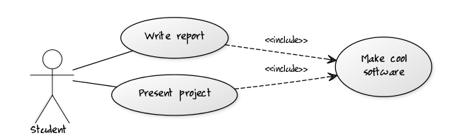
Figure 3.1 Use case diagram showing the role of the student

Testing
Describe the steps or methods you use to validate your results.
How did you test your software? Can you show that you tested it in a real world situation or on actual users in the target group that you described in the background/objectives. Describe the situation.

Results and Discussion

Results
What results did you gain from the testing? What changes did you make?

Discussion
Discuss the results according to your objectives. What are strengths of this project comparing to others? What are limitations and their reasons?

Conclusions

Conclusions
Summarise the main outcomes of the project. Explain any challenges.

Limitations
List all limitations of the project.

Recommendations
Describe possible future work.

References
[1] Dave Mark, Jeff LaMarche. Beginning iPhone Development: Exploring the iPhone SDK. Apress, July 2009.
[2] Apple. “iOS Developer Library”. Available from: http://developer.apple.com/library/ios/ (Accessed 31-Mar-2014)

[use Style > “references”]

Appendix

Appendix A: Database Schema
[Content starts here]

Appendix B: Tutorial
[Content starts here]

